5.4 Green’s Theorem Worksheet

- Consider the work done by the vector field on a particle moving counterclockwise around the unit circle.
- Use Green’s Theorem to evaluate the resulting line integral.

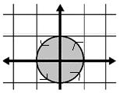
A picture of the curve C and implied region D are shown at the right.

Here, .

We note that and so .
We see that C is a positively oriented, piecewise-smooth, simple closed curve in the xy-plane and that P and Q have continuous first order partial derivatives on D.

Therefore, by Green’s Theorem,

- How would your answer change if the particle was moving clockwise around the unit circle?

Moving in the clockwise direction would change our path C to –C. Thus, the only difference would be that the total work would be multiplied by negative one.
.

- Use Green’s Theorem to evaluate the line integral where and C is the triangle joining , , and in the counterclockwise direction.

A picture of the curve C and implied region D are shown at the right.
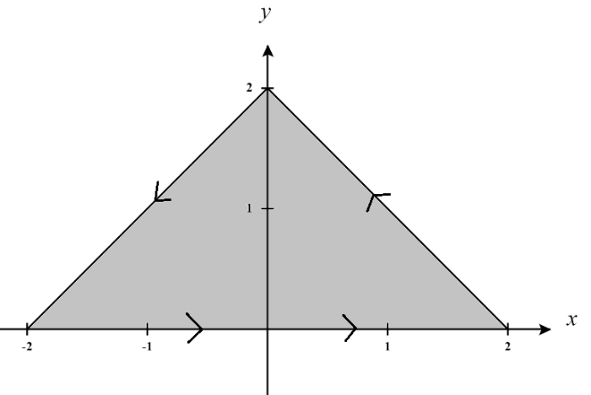
Here, .

We note that and so .
We see that C is a positively oriented, piecewise-smooth, simple closed curve in the xy-plane and that P and Q have continuous first order partial derivatives on D.

Therefore, by Green’s Theorem,

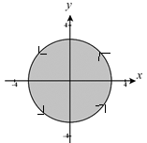
- Evaluate , where C is the circle .

A picture of the curve C and implied region D are shown at the right.

Here, .

We note that and so .
We see that C is a positively oriented, piecewise-smooth, simple closed curve in the xy-plane and that P and Q have continuous first order partial derivatives on D.

Therefore, by Green’s Theorem,

- Suppose an object is being spun by high wind currents modelled by the vector field in a counterclockwise fashion around a circle of radius 2. Determine the total work done by the wind currents on the object as the object moves around the circle once.
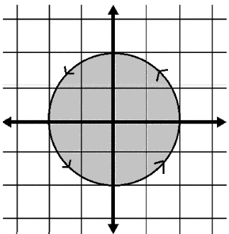
A picture of the curve C and implied region D are shown at the right.

Here, .

We note that and so .
We see that C is a positively oriented, piecewise-smooth, simple closed curve in the xy-plane and that P and Q have continuous first order partial derivatives on D.

Therefore, by Green’s Theorem,

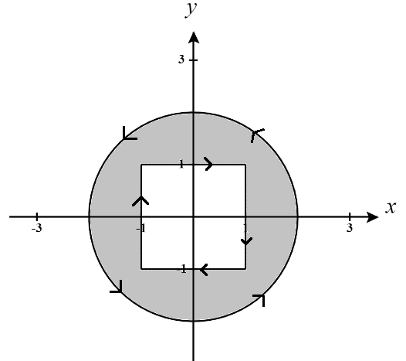
- Determine the work done by the vector field on a particle moving along C, where C is the boundary of the region outside the unit square but inside the circle with positive orientation.
A picture of the curve C and implied region D are shown at the right.

We note that and so .
We see that C is a positively oriented, piecewise-smooth, simple closed curve in the xy-plane and that P and Q have continuous first order partial derivatives on D.

Therefore, by Green’s Theorem,

We know from basic geometry that the area of the region is given by

Thus,

- Use Green’s Theorem to evaluate the line integral along the given positively oriented curve.

where C is the boundary of the region enclosed by the parabolas and .
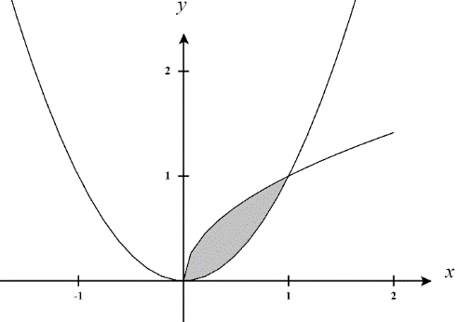
A picture of the curve C and implied region D are shown at the right.

Here, .

We note that and so .
We see that C is a positively oriented, piecewise-smooth, simple closed curve in the xy-plane and that P and Q have continuous first order partial derivatives on D.

Therefore, by Green’s Theorem,

- Explain why green’s theorem cannot be used to evaluate the following line integral:

where C is the boundary of positively oriented unit circle.

A picture of the curve C and implied region D are shown at the right.

Here, .

We note that and so .
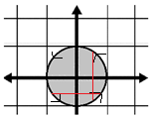
We see that C is a positively oriented, piecewise-smooth, simple closed curve in the xy-plane. However, we see that is discontinuous when and is discontinuous when . Therefore, the first partials are not continuous on D. In fact, the first partials at all points shown in red in the picture to the right.

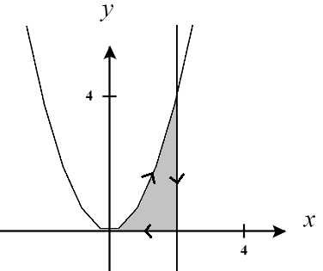
- Compute , where C is the negatively oriented boundary of the region enclosed by , the x-axis, and .

A picture of the curve C and implied region D are shown at the right.

Here, .

We note that and so .
We see that -C is a positively oriented, piecewise-smooth, simple closed curve in the xy-plane and that P and Q have continuous first order partial derivatives on D.

Therefore, by Green’s Theorem,

- Use Green’s Theorem to evaluate the following line integral where C is the path from to along a line, followed by the path from to along the top half of a circle of radius 3 centered at the origin, followed by the path from to along a line, followed by the path from to along the top half of a circle of radius 1 centered at the origin.
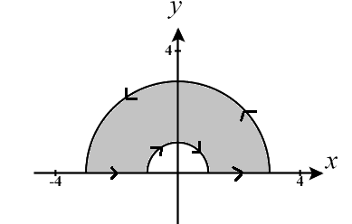
A picture of the curve C and implied region D are shown at the right.
Here, .
We note that and so .
We see that C is a positively oriented, piecewise-smooth, simple closed curve in the xy-plane and that P and Q have continuous first order partial derivatives on D.

Therefore, by Green’s Theorem,

- Evaluate , where C is the ellipse .

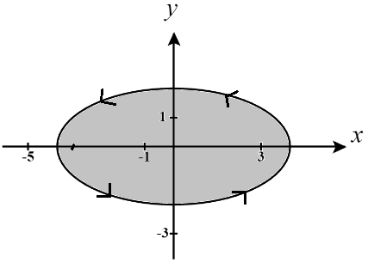
A picture of the curve C and implied region D are shown at the right.

We note that and so .
We see that C is a positively oriented, piecewise-smooth, simple closed curve in the xy-plane and that P and Q have continuous first order partial derivatives on D.

Therefore, by Green’s Theorem,

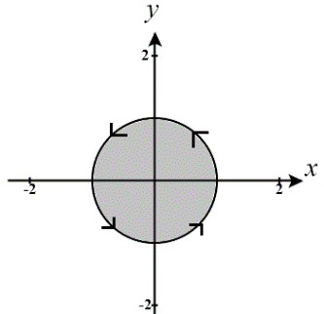
To calculate this more easily we will use a change of variables to rework the region D into the unit circle.

Let then we see that S is determined by
So, and has the following picture

Therefore, our transformation is and the Jacobian of this transformation is
Thus,
NOTE: You may notice that in general the area of an ellipse is given by where a & b are the radii in each direction of the ellipse. In the example above we have and thus

